

4-REQUEST FIRST COME FIRST SERVE ARBITER

ADLD
COURSE PROJECT

Sno. | Name | USN
1. | Safiya Mohsin | 01FE20BEC332
2. | Pramath | 01FE20BEC082

INTRODUCTION
Usually multiple task are done at a same time in the computer. While using a computer, many functions like creating a document, playing music, copying some files etc are performed simultaneously. All these functions are controlled by master system software called Operating system. All the processes in the system have to use some common resources like memory block, Io ports etc. When these processes simultaneously want to Access the common shared resources, the operating system has to decide to which process the resource has to be allocated.
For deciding to which process the resource has to be allocated, there is a device called Arbiter. An arbiter is a device that resolves the shared resource conflict between the processes. It performs many scheduling algorithms. Some of them include Round-robin algorithm, First come first serve (FCFS) algorithm, Shortest job First (SJF) algorithm etc. Round-robin algorithm allocates resource for equal amount of time slots to each of the processes. Shortest job First algorithm allocates resource to that process whose job finishes soon i.e. the process that requires the resource for shorter time. First come first serve algorithm allocates resource to that process who has requested early.
FCFS follows the queue pattern where the process requesting first will be granted the access first while others processes have to wait until the running process completes its task. Consider the example of four processes requesting to access the resource and it's seen that the second process has requested first, then arbiter decides to grant access to the second process and the same pattern continues for the remaining three processes.
In the case where more than one process request at same time, then the arbiter decides on the basis of the priority assigned to the processes.

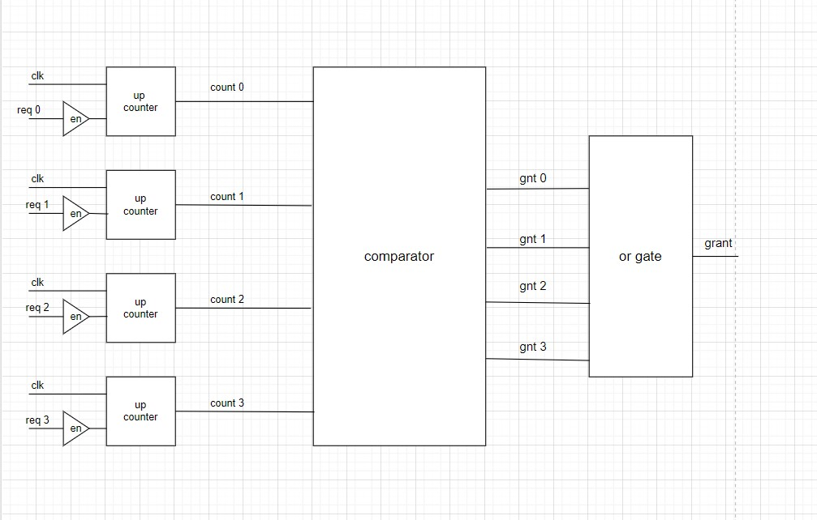
FCFS Architecture

Four processors are considered for the conflict of sharing resource as shown in Fig. The processors are sending requests. These requests are sent to the counter module where once the module accepts the request, it starts counting. The count values for four processors are obtained as the output of counter block. These count values are fed as input to the comparator module where the values are compared and the one with highest count value is granted with the resource.

Once the processor is granted the resource read-write (rd-wr) signal is made either high or low. If rd-wr is high then the processor is allowed to write into memory else it can read from the memory. The processor must specify the burst time for its task and has to continue doing the same for the defined amount of time. If the burst time is not defined externally by the processor then default cycles are taken as 128 clock cycles.

SPECIFICTAIONS FOR THE DESIGN
1. 4 input port for 4 devices
2. 4 output ports for 4 grants
3. 1 input port for clock
4. 1 input port for reset button
5. 4 registers for holding count values

SIMULATION
The proposed design is coded in Verilog HDL and simulated using ISE 14.1. Synthesizes and verified using Xilinx ISE. Allocating memory to the device after the processor is granted. Initial task was to grant the access to the requesting processors. The obtained result from the FCFS block and RAM address acts as inputs to the RAM module. In this module the processors granted with the resource are checked and allot the read or write operation accordingly. The read write operation output is shown in Output is shown in Fig 2. An example is shown in the below figure, it is observed that at second positive edge of the clock only req1 is 1, so according to the FCFS scheme grant1 is made high. The rd-wr signal for the same is 1, so the value 0101 is written in the memory address the specified address.
RESULTS
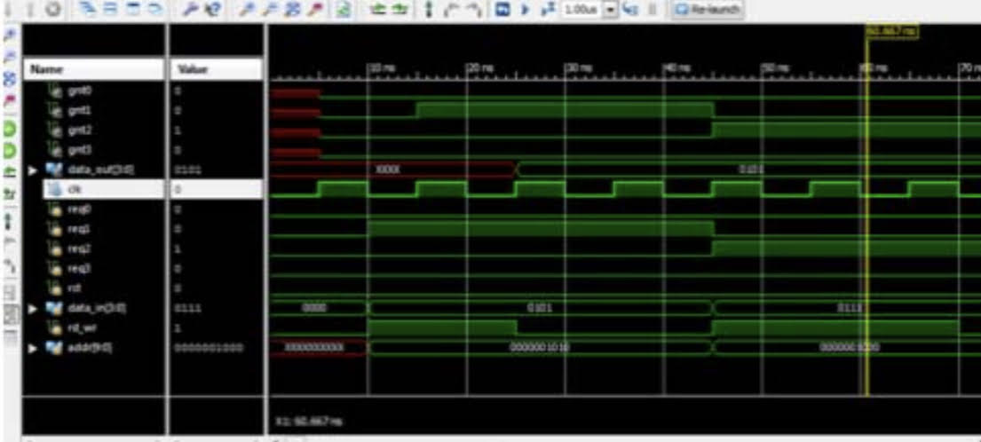

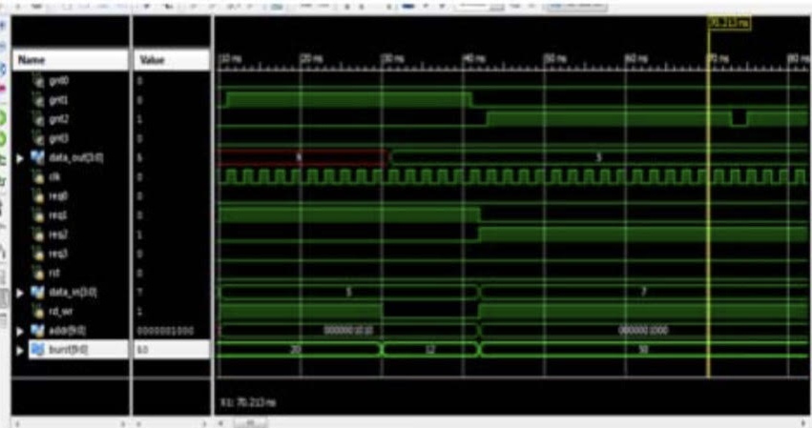
Output showing the burst time

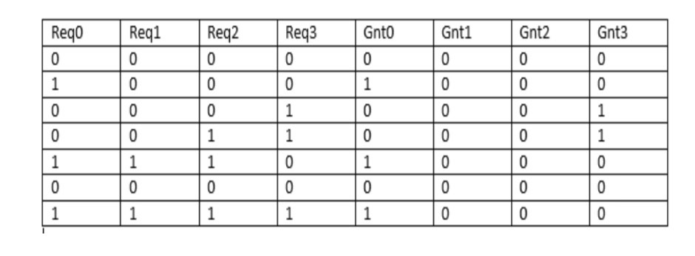
Truth table of FCFS Arbiter

Clearly explains the functionality of the FCFS algorithm. As shown if Processor ‘0’requests (Req0) the grant is provided (Gnt0). If more than one processor request for the slave (Req0, Req1, Req2) are equal to 1 the grant is given to the processor requesting first(Gnt0)
CONCLUSION
The FCFS scheduling algorithm is the simplest scheduling algorithm, but it can cause short processors to wait for very long until a processor with longer duration task completes its job. Here complete ASIC flow for FCFS arbiter is performed where RTL designing is done using Verilog language and verification is performed using System Verilog language which validates the functionality of the design.

